
EBITCASH FINOTE
February 2024

This is complete and technical analysis of all financial activity which effect global and domestic stock market in month of february.
1. Budget- India get their financial statement on 1st of february 2024.this is a continuation of current budget because of electorial event in April 2024.infrastructure and research are two main outcome for future.stock market take this in positive side and continue their trend and expect growth will continue.
Important data of Budget-

2.GDP data- India get their Q3 GDP data on 29th of february.8.4% growth shown in this data means 8.4% more product was produce in this quater in compare to previous year. this shows supply side only, for whole growth story we need to know consumption data which is not easy to record,so we expect this data is in response of demand,get a conclusion that supply shows the demand and both shows growth.this data also taken positively by market.
Important data of GDP-

3.FED-release- fedral reserve resume their interest rate on 27th february and told inflation will come down in our economy and balance demand and supply disbalance and make economy more sustainable and stable with current interest rate.US and all global market take this positively.
Important data of FED-

4.SEBI Action-Market regulator SEBI in an interim order asked several guest experts appearing on the Zee Business news channel to cough up Rs 7.41 crore “unlawful gain” that they made by taking opposite positions in the market than they advised on air.
Action has been taken against 15 experts appearing on the channel between February 01, 2022 and December 31, 2022. Some of them were directly involved in taking such unlawful trades, while others enabled them. Some of them have also been barred from trading in the market until further orders, SEBI said in its order on February 8.
They include Simi Bhaumik, Mudit Goyal Himanshu Gupta, Ashish Kelkar, Kiran Jadhav, Ramawatar Lalchand Chotia, SAAR Securities India Private Limited, Ajaykumar Ramakant Sharma, Rupesh Kumar Matoliya, Nitin Chhalani, Kanhya Trading Company, Manan Sharecom Private Limited, SAAR Commodities Private Limited, Partha Sarathi Dhar and Nirmal Kumar Soni.
SEBI categorised them in three categories. Kiran Jadhav, Ashish Kelkar, Himanshu Gupta, Mudit Goyal, and Simi Bhaumik were involved in giving trading advice to viewers, and hence have been bracketed as guest experts. Nirmal Kumar Soni, Partha Sarathi Dhar, SAAR Commodities, Manan Sharecom and Kanhya Trading Company have been termed profit makers and rest are enablers.
our conclusion- All investor and traders please beware from all fraud done through leading media broadcaster and learn share market first.
Market analysis- market are at all time high except some sector like IT and metal so we have to concentrate our focus to these sector for future.
some interesting chart and data-
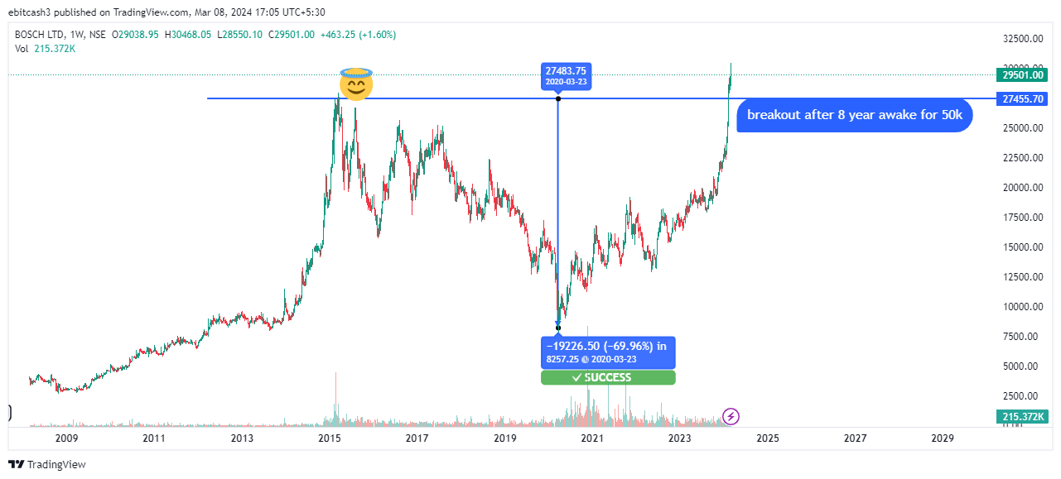
Bosch is at 28000 level and my prediction of 50000 for long term with lowest risk.
Message for investors and partners
Dear
Partners/Investors/Learner

we all are working for Ebitcash & k from different geographical place but our
vission is centre for a specific goal that is “grow with growing economy”.here is some devlopment which were happen in past small frame of time.

1. Ebitcash family is growing day by day we initiate from a idea and now we reached 25+ member.
2.Our online presence through website,social media page is increasing day by day
3.capital allocation on different platform work properly.
4.After three major financial event market is stable that is good for us and expect a good time for market ahead all sebi notices are in favour of retailer that is good for us and slowly and steadily we are going to hit our one year plan.

Thank you all for believe on EBITCASH


